| Pin 1 | Pin 2 | Output |
| --- | --- | --- |
| 0 | 0 | 0 |
| 0 | 1 | 0 |
| 1 | 0 | 0 |
| 1 | 1 | 1 |

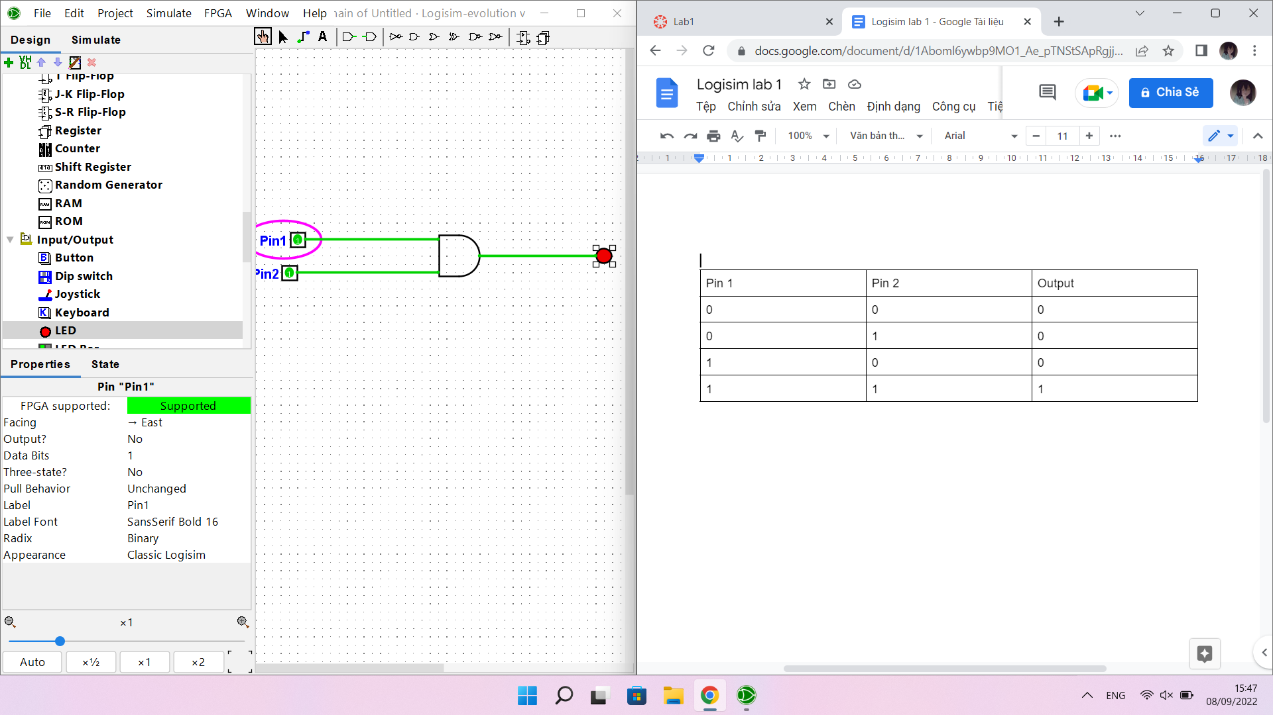

| Pin | Output |
| --- | --- |
| 0 | 1 |
| 1 | 0 |

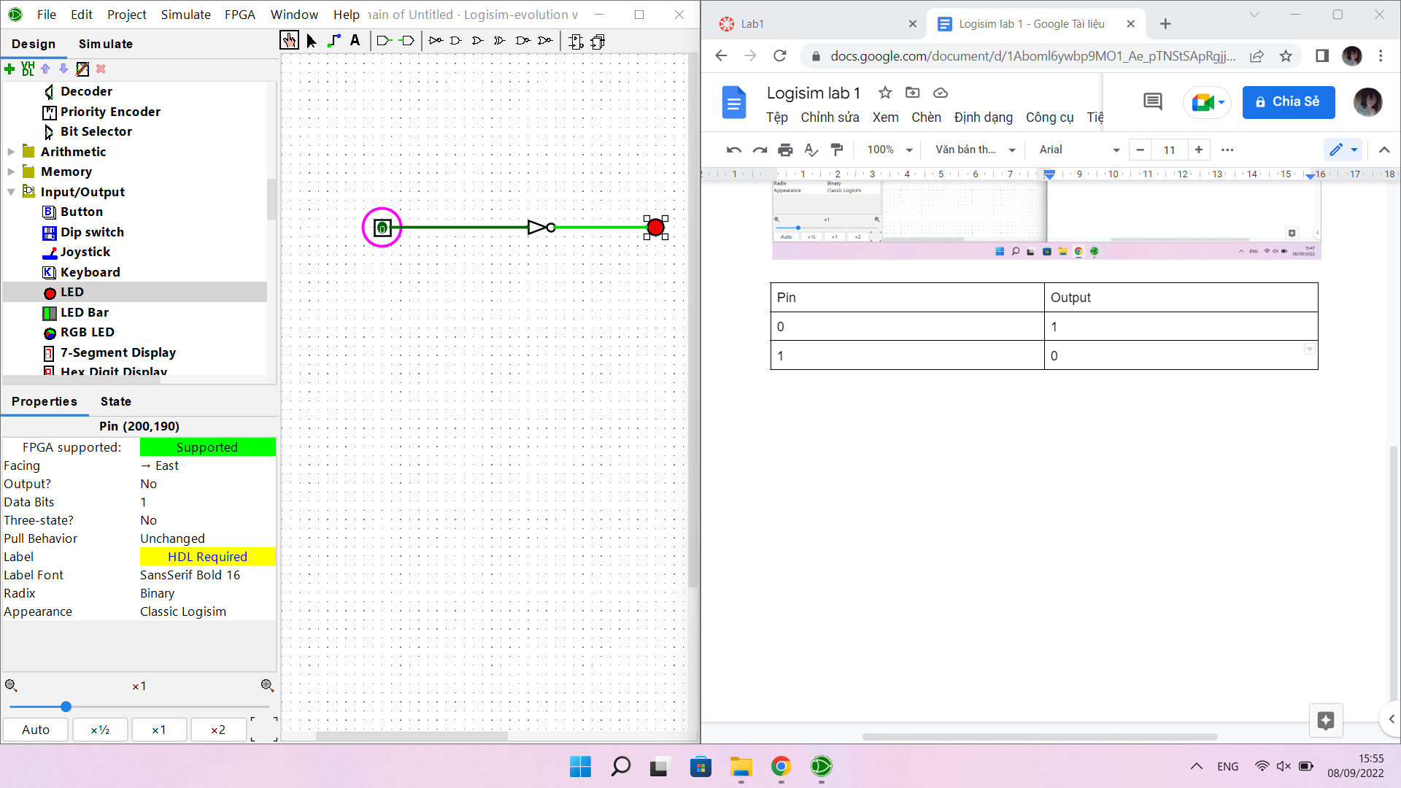

| Pin 1 | Pin 2 | Output |
| --- | --- | --- |
| 0 | 0 | 1 |
| 0 | 1 | 1 |
| 1 | 0 | 1 |
| 1 | 1 | 0 |

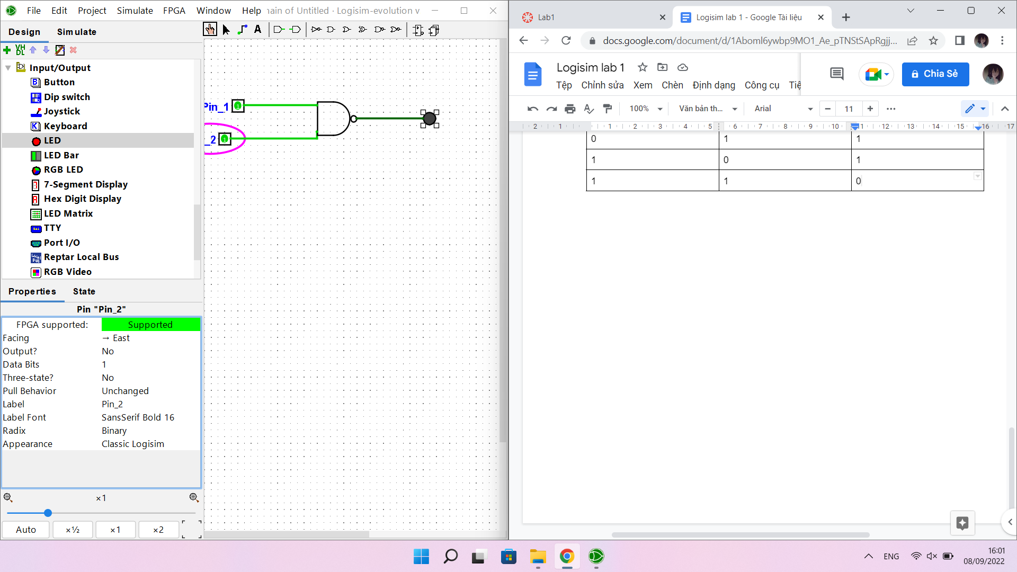

| Input 1 | Input 2 | Sum output | Carry output |
| --- | --- | --- | --- |
| 0 | 0 | 0 | 0 |
| 0 | 1 | 1 | 0 |
| 1 | 0 | 1 | 0 |
| 1 | 1 | 0 | 1 |

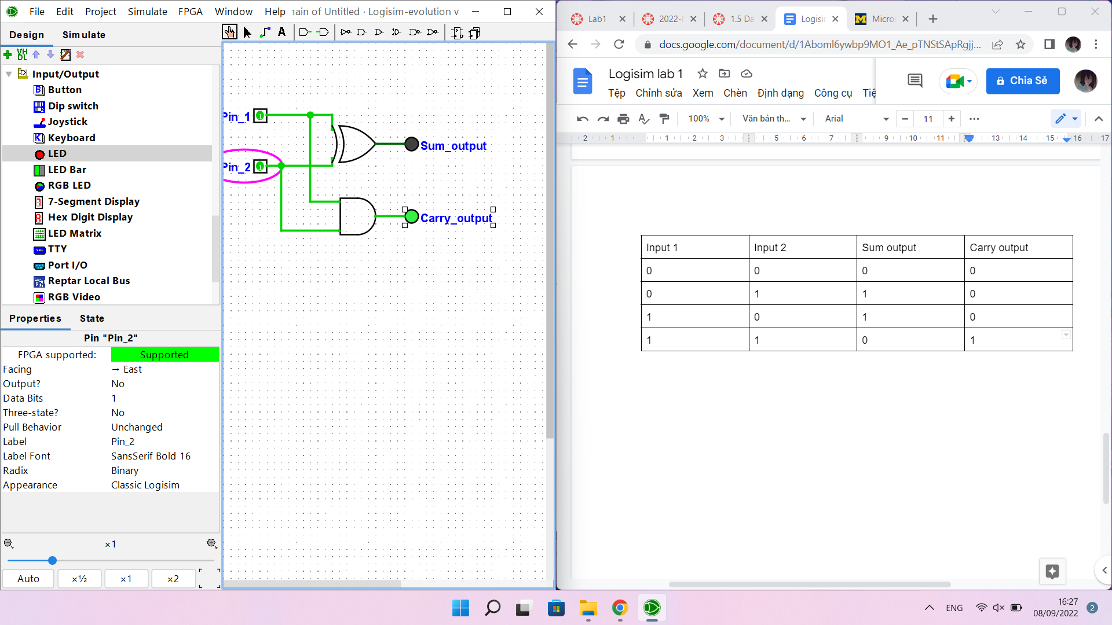

| Input 1 | Input 2 | Carry in | Sum output | Carry output |
| --- | --- | --- | --- | --- |
| 0 | 0 | 0 | 0 | 0 |
| 0 | 1 | 0 | 1 | 0 |
| 1 | 0 | 0 | 1 | 0 |
| 1 | 1 | 0 | 0 | 1 |
| 0 | 0 | 1 | 1 | 0 |
| 0 | 1 | 1 | 0 | 1 |
| 1 | 0 | 1 | 0 | 1 |
| 1 | 1 | 1 | 1 | 1 |

